# Supplementary Materials 2

CellGiQ: Identifying potential ligand-receptor interactions and its application in cell-cell communication inference

Lihong Peng, Pengfei Gao, Wei Xiong, Zejun Li*, and Xing Chen*

## List of figures and tables:

**Fig. S1:** The bubble plots delineating the top 3 LRIs base on the expression product approach

**Fig. S2:** The bubble plots delineating the top 3 LRIs base on the specific expression approach

**Fig. S3:** The bubble plots delineating the top 3 LRIs base on the quartile scoring strategy

**Table S1:** The molecular docking data for randomly selected 30 LRIs on dataset1

**Table S2:** The molecular docking data for randomly selected 30 LRIs on dataset2

**Table S3:** The molecular docking data for randomly selected 30 LRIs on dataset3

**Table** **S4:** The molecular docking data for randomly selected 30 LRIs on dataset4

**Table S5:** The CCC strength computed by the expression thresholding approach

**Table S6:** The CCC strength computed by the expression product approach

**Table S7:** The CCC strength computed by the specific expression approach

**Table S8:** The CCC strength computed by the quartile scoring strategy approach

**Table S9:** The CCC scores computed by CellChat

**Table S10:** The CCC scores computed by CellEnBoost_p

**Table S11:** The CCC scores computed by CellEnBoost_s

**Table S12:** The CCC scores computed by CellEnBoost_c

**Table S13:** The CCC scores computed by CellComNet

**Table S14:** The CCC scores computed by iTalk

**Table S15:** The CCC scores computed by LIANA

**Table S16:** The CCC scores computed by CellPhoneDB

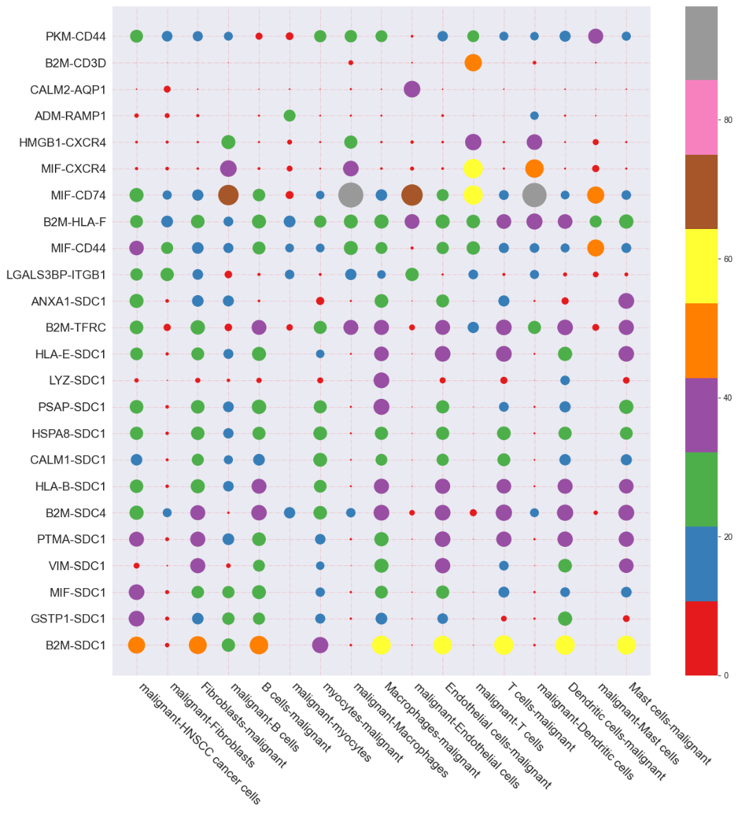

**Fig. S1** The bubble plots delineating the top 3 LRIs base on the expression product approach

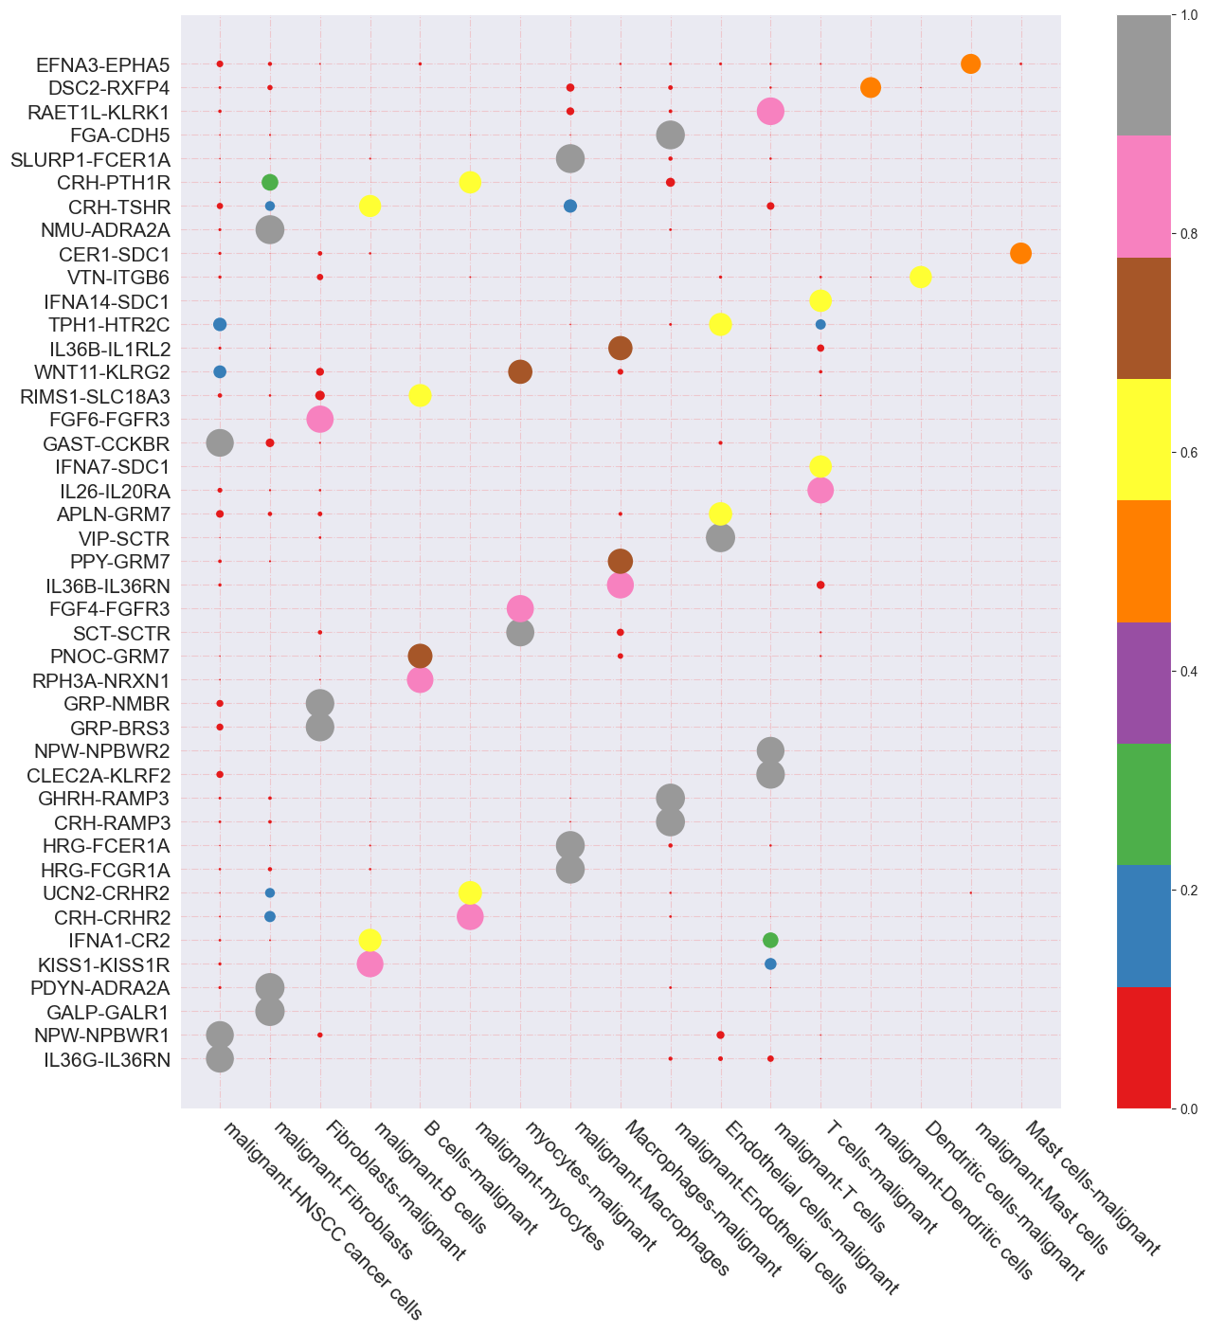

**Fig. S2** The bubble plots delineating the top 3 LRIs based on the specific expression approach

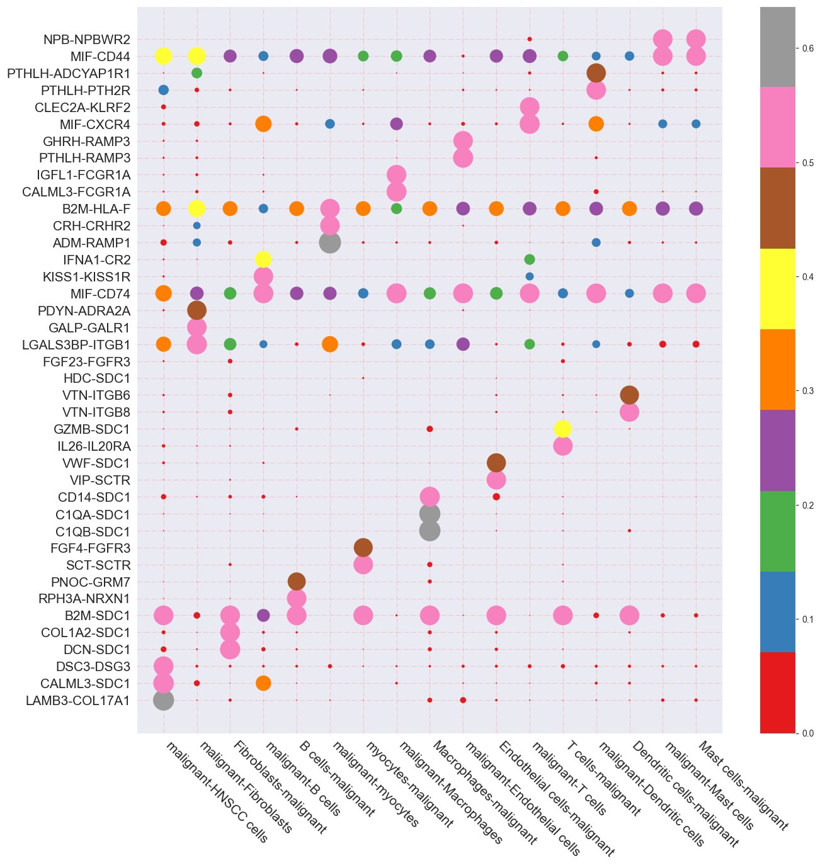

**Fig. S3** The bubble plots delineating the top 3 LRIs based on the quartile scoring strategy

**Table S1** The molecular docking data for randomly selected 30 LRIs on dataset 1

|  |  |  |  |  |  |  |  |
| --- | --- | --- | --- | --- | --- | --- | --- |
|  | Ligand-Receptor | LRI  (Gene Names) | Molecular docking | Binding energy (kcal/mol) | Interface area  (**Å2)** | Hydrogen bonds (**Å)** | Salt bridges (**Å)** |
| 1 | ENSP00000283147 ENSP00000370542 | BMP6_SDC1 |  | -33.3 | 2015.9 | 3.9 | 3.83 |
| 2 | ENSP00000363492 ENSP00000370542 | GDF5_SDC1 |  | -39.3 | 2616.3 | 3.84 | 3.98 |
| 3 | ENSP00000284981 ENSP00000370542 | APP_SDC1 |  | -7.6 | 629.3 | 3.28 | 2.52 |
| 4 | ENSP00000312999 ENSP00000370542 | GNAI2_SDC1 |  | -37.9 | 2192.1 | 3.77 | 3.49 |
| 5 | ENSP00000225844 ENSP00000370542 | CCL13_SDC1 |  | -27.3 | 2414.6 | 3.67 | 3.08 |
| 6 | ENSP00000482232 ENSP00000370542 | CGA_SDC1 |  | -10.4 | 733.3 | 3.59 |  |
| 7 | ENSP00000469689 ENSP00000370542 | SHANK2_SDC1 |  | -14.1 | 1877.6 | 3.71 | 3.97 |
| 8 | ENSP00000283147 ENSP00000357097 | BMP6_FCER1A |  | -24.7 | 1515.8 | 3.85 | 3.91 |
| 9 | ENSP00000363492 ENSP00000357097 | GDF5_FCER1A |  | -34.0 | 1915.1 | 3.86 |  |
| 10 | ENSP00000312999 ENSP00000357097 | GNAI2_FCER1A |  | -37.9 | 2192.1 | 3.82 | 3.49 |
| 11 | ENSP00000225844 ENSP00000357097 | CCL13_FCER1A |  | -16.0 | 1235.6 | 3.81 |  |
| 12 | ENSP00000469689 ENSP00000357097 | SHANK2_FCER1A |  | -6.6 | 840.6 | 3.61 | 2.61 |
| 13 | ENSP00000398698 ENSP00000357097 | TNF_FCER1A |  | -17.5 | 800.3 | 3.8 | 3.80 |
| 14 | ENSP00000284523 ENSP00000357097 | WNT3A_FCER1A |  | -45.7 | 3942.4 | 3.88 | 3.65 |
| 15 | ENSP00000215781 ENSP00000361818 | OSM_SDC4 |  | -5.7 | 550.2 | 3.78 | 3.92 |
| 16 | ENSP00000276927 ENSP00000361818 | IFNA1_SDC4 |  | -12 | 1996.3 | 3.78 | 3.92 |
| 17 | ENSP00000369571 ENSP00000361818 | IFNA14_SDC4 |  | -15.1 | 2094.9 | 3.86 | 3.92 |
| 18 | ENSP00000412897 ENSP00000361818 | IFNA4_SDC4 |  | -8.2 | 1175.2 | 3.78 | 3.92 |
| 19 | ENSP00000352455 ENSP00000361818 | MFAP5_SDC4 |  | -14.8 | 1839.4 | 3.84 | 3.92 |
| 20 | ENSP00000378326 ENSP00000361818 | ZP3_SDC4 |  | -15.7 | 1973.2 | 3.78 | 3.92 |
| 21 | ENSP00000292401 ENSP00000361818 | AZGP1_SDC4 |  | -14.2 | 1638.6 | 3.78 | 3.92 |
| 22 | ENSP00000266058 ENSP00000361818 | SLIT1_SDC4 |  | -8.8 | 1569.8 | 3.78 | 3.92 |
| 23 | ENSP00000220809 ENSP00000361818 | PLAT_SDC4 |  | -15 | 1683.6 | 3.78 | 3.92 |
| 24 | ENSP00000376921 ENSP00000361818 | NTNG2_SDC4 |  | -10.7 | 1424.1 | 3.78 | 3.92 |
| 25 | ENSP00000321797 ENSP00000361818 | FGF8_SDC4 |  | -12.1 | 1638.6 | 3.78 | 3.92 |
| 26 | ENSP00000215781 ENSP00000358165 | OSM_FCGR1A |  | -16.6 | 2243.5 | 3.86 | 3.78 |
| 27 | ENSP00000276927 ENSP00000358165 | IFNA1_FCGR1A |  | -21.7 | 2959.4 | 3.79 | 3.92 |
| 28 | ENSP00000369571 ENSP00000358165 | IFNA14_FCGR1A |  | -16.9 | 2240.2 | 3.73 | 3.69 |
| 29 | ENSP00000215530ENSP00000361818 | FGF22_SDC4 |  | -11.2 | 1341.7 | 3.78 | 3.92 |
| 30 | ENSP00000357722  ENSP00000361818 | S100A8_SDC4 |  | -37.8 | 2173.5 | 3.78 | 3.92 |

**Table S2** The molecular docking data for randomly selected 30 LRIs on dataset 2

|  |  |  |  |  |  |  |  |
| --- | --- | --- | --- | --- | --- | --- | --- |
|  | Ligand receptor | LRI  (Gene Names) | Molecular docking | Binding energy (kcal/mol) | Interface area  (**Å2)** | Hydrogen bonds (**Å)** | Salt bridges (**Å)** |
| 1 | ENSMUSP00000125697 ENSMUSP00000059270 | Gng2_Gp1bb |  | -41.1 | 2166.6 | 3.68 | 3.55 |
| 2 | ENSMUSP00000030187 ENSMUSP00000059270 | Tln1_Gp1bb |  | -13.2 | 732.1 | 3.65 | 3.64 |
| 3 | ENSMUSP00000039600 ENSMUSP00000059270 | Ccl5_Gp1bb |  | -21.9 | 1224.7 | 3.6 |  |
| 4 | ENSMUSP00000022369 ENSMUSP00000059270 | Vcl_Gp1bb |  | -38.6 | 1833.4 | 3.74 | 3.68 |
| 5 | ENSMUSP00000074885 ENSMUSP00000059270 | Cxcl2_Gp1bb |  | -17.8 | 1188.0 | 3.8 |  |
| 6 | ENSMUSP00000032561 ENSMUSP00000059270 | Vasp_Gp1bb |  | -15.8 | -15.8 | 2.81 |  |
| 7 | ENSMUSP00000040412 ENSMUSP00000059270 | Tnfsf9_Gp1bb |  | -17.1 | 1152.2 | 3.85 | 3.59 |
| 8 | ENSMUSP00000003274 ENSMUSP00000059270 | Ebi3_Gp1bb |  | -14.4 | 637.8 | 3.87 | 3.79 |
| 9 | ENSMUSP00000002979 ENSMUSP00000043936 | Lamb1_Htr2c |  | -0.6 | 427.2 | 3.69 | 3.98 |
| 10 | ENSMUSP00000118318 ENSMUSP00000043936 | Afdn_Htr2c |  | -35.7 | 2223.0 | 3.84 |  |
| 11 | ENSMUSP00000050716 ENSMUSP00000043936 | Efnb1_Htr2c |  | -12.1 | 1089.4 | 3.89 | 3.49 |
| 12 | ENSMUSP00000016640 ENSMUSP00000043936 | Cd274_Htr2c |  | -8.3 | 811.5 | 3.53 | 3.42 |
| 13 | ENSMUSP00000028233 ENSMUSP00000043936 | C5_Htr2c |  | -12.9 | 1028.4 | 3.86 |  |
| 14 | ENSMUSP00000125697 ENSMUSP00000003469 | Gng2_Cd79a |  | -73.4 | 3975.9 | 3.82 | 3.96 |
| 15 | ENSMUSP00000030187 ENSMUSP00000003469 | Tln1_Cd79a |  | -38.4 | 2523.9 | 3.83 | 3.96 |
| 16 | ENSMUSP00000038301 ENSMUSP00000003469 | Gdf7_Cd79a |  | -37.5 | 2343.7 | 3.83 | 3.96 |
| 17 | ENSMUSP00000058951 ENSMUSP00000003469 | Angptl8_Cd79a |  | -49.2 | 2795.8 | 3.83 | 3.96 |
| 18 | ENSMUSP00000042705 ENSMUSP00000003469 | Gng10_Cd79a |  | -39.8 | 2163 | 3.83 | 3.96 |
| 19 | ENSMUSP00000004480 ENSMUSP00000003469 | Sst_Cd79a |  | -36.5 | 1990.9 | 3.83 | 3.96 |
| 20 | ENSMUSP00000039600 ENSMUSP00000003469 | Ccl5_Cd79a |  | -46.2 | 2970 | 3.83 | 3.96 |
| 21 | ENSMUSP00000077314 ENSMUSP00000003469 | Gng8_Cd79a |  | -41.6 | 2152.6 | 3.83 | 3.96 |
| 22 | ENSMUSP00000041047 ENSMUSP00000003469 | Pth2_Cd79a |  | -54.4 | 2760.3 | 3.83 | 3.96 |
| 23 | ENSMUSP00000049161 ENSMUSP00000003469 | Ctf1_Cd79a |  | -28.4 | 2244.7 | 3.83 | 3.96 |
| 24 | ENSMUSP00000030384 ENSMUSP00000003469 | Edn2_Cd79a |  | -17.9 | 2485 | 3.83 | 3.96 |
| 25 | ENSMUSP00000109064 ENSMUSP00000003469 | Ccl20_Cd79a |  | -33.4 | 1856.1 | 3.83 | 3.96 |
| 26 | ENSMUSP00000035120 ENSMUSP00000003469 | Cck_Cd79a |  | -21.8 | 1882.6 | 3.83 | 3.96 |
| 27 | ENSMUSP00000031318 ENSMUSP00000003469 | Cxcl5_Cd79a |  | -42.7 | 2315.4 | 3.83 | 3.96 |
| 28 | ENSMUSP00000067057 ENSMUSP00000003469 | Adcyap1_Cd79a |  | -23.3 | 2152.7 | 3.83 | 3.96 |
| 29 | ENSMUSP00000002708 ENSMUSP00000003469 | Shh_Cd79a |  | -18.7 | 1897 | 3.83 | 3.96 |
| 30 | ENSMUSP00000025914 ENSMUSP00000003469 | Vegfb_Cd79a |  | -27 | 2261.2 | 3.83 | 3.96 |

**Table S3** The molecular docking data for randomly selected 30 LRIs on dataset 3

|  |  |  |  |  |  |  |  |
| --- | --- | --- | --- | --- | --- | --- | --- |
|  | Ligand-Receptor | LRI  (Gene Names) | Molecular docking | Binding energy (kcal/mol) | Interface area  (**Å2)** | Hydrogen bonds (**Å)** | Salt bridges (**Å)** |
| 1 | ENSMUSG00000035042 ENSMUSG00000034664 | Ccl5_Itga6b |  | -17.1 | 1118.6 | 3.76 |  |
| 2 | ENSMUSG00000031302 ENSMUSG00000034664 | Nlgn3_Itga2b |  | -17.1 | 1036.5 |  | 3.59 |
| 3 | ENSMUSG00000022015 ENSMUSG00000034664 | Tnfsf11_Itga2b |  | -12.4 | 1979.5 | 3.86 | 3.97 |
| 4 | ENSMUSG00000026697 ENSMUSG00000034664 | Myoc_Itga2b |  | -14 | 1656.9 | 3.8 | 3.97 |
| 5 | ENSMUSG00000031302 ENSMUSG00000033191 | Nlgn3_Tie1 |  | -27.1 | 2886.8 | 3.62 | 3.93 |
| 6 | ENSMUSG00000022015 ENSMUSG00000033191 | Tnfsf11_Tie1 |  | -14.6 | 2065.5 | 3.88 | 3.98 |
| 7 | ENSMUSG00000026697 ENSMUSG00000033191 | Myoc_Tie1 |  | -7.9 | 1183.7 | 3.8 | 3.79 |
| 8 | ENSMUSG00000035042 ENSMUSG00000033191 | Ccl5_Tie1 |  | -11.1 | 1352.7 | 3.83 | 3.85 |
| 9 | ENSMUSG00000035042 ENSMUSG00000024913 | Ccl5_Lrp5 |  | -10.1 | 1424.6 | 3.57 | 3.69 |
| 10 | ENSMUSG00000038300 ENSMUSG00000024620 | Pth2_Pdgfrb |  | -16.9 | 827.6 | 3.75 |  |
| 11 | ENSMUSG00000035042 ENSMUSG00000024620 | Ccl5_Pdgfrb |  | -14.6 | 1238.2 | 3.72 |  |
| 12 | ENSMUSG00000042340 ENSMUSG00000024620 | Ctf1_Pdgfrb |  | -16.9 | 827.6 | 3.75 |  |
| 13 | ENSMUSG00000028635 ENSMUSG00000024620 | Edn2_Pdgfrb |  | -13.2 | 520.6 | 3.66 | 3.66 |
| 14 | ENSMUSG00000004366 ENSMUSG00000024620 | Sst_Pdgfrb |  | -13.2 | 520.6 | 3.66 | 3.66 |
| 15 | ENSMUSG00000035042 ENSMUSG00000002897 | Ccl5_Il17ra |  | -18.5 | 2607.3 | 3.9 | 4 |
| 16 | ENSMUSG00000026166 ENSMUSG00000024620 | Ccl20_Pdgfrb |  | -13.9 | 607.1 | 3.86 | 3.62 |
| 17 | ENSMUSG00000037660 ENSMUSG00000024620 | Gdf7_Pdgfrb |  | -15.2 | 734.6 | 3.59 |  |
| 18 | ENSMUSG00000064057 ENSMUSG00000024620 | Scgb3a1_Pdgfrb |  | -16.5 | 698.3 | 3.58 |  |
| 19 | ENSMUSG00000032532 ENSMUSG00000024620 | Cck_Pdgfrb |  | -13.9 | 623.3 | 3.73 | 3.32 |
| 20 | ENSMUSG00000039481 ENSMUSG00000024620 | Nrtn_Pdgfrb |  | -15.8 | 715.8 | 3.75 |  |
| 21 | ENSMUSG00000045232 ENSMUSG00000024620 | Rln3_Pdgfrb |  | -20.8 | 1496.7 | 3.53 | 2.84 |
| 22 | ENSMUSG00000031302 ENSMUSG00000024913 | Nlgn3_Lrp5 |  | -29.3 | 2208.3 | 3.86 | 3.86 |
| 23 | ENSMUSG00000022015 ENSMUSG00000024913 | Tnfsf11_Lrp5 |  | -14.9 | 1882.9 | 3.88 | 3.98 |
| 24 | ENSMUSG00000035042 ENSMUSG00000039115 | Ccl5_Itga9 |  | -11.5 | 1134.7 | 3.77 |  |
| 25 | ENSMUSG00000027301 ENSMUSG00000024620 | Oxt_Pdgfrb |  | -13.8 | 611.1 | 3.49 |  |
| 26 | ENSMUSG00000048163 ENSMUSG00000024620 | Selplg_Pdgfrb |  | -13.5 | 623.0 | 3.75 |  |
| 27 | ENSMUSG00000024659 ENSMUSG00000024620 | Anxa1_Pdgfrb |  | -13.7 | 629.7 | 3.59 |  |
| 28 | ENSMUSG00000022483 ENSMUSG00000024620 | Col2a1_Pdgfrb |  | -29.2 | 2223.0 | 3.86 | 3.87 |
| 29 | ENSMUSG00000022015 ENSMUSG00000055471 | Tnfsf11_Alk |  | -21.7 | 2819.1 | 3.86 | 3.97 |
| 30 | ENSMUSG00000035042 ENSMUSG00000031385 | Ccl5_Plxnb3 |  | -18.5 | 1237.9 | 3.6 |  |

**Table S4** The molecular docking data for randomly selected 30 LRIs on dataset4

|  |  |  |  |  |  |  |  |
| --- | --- | --- | --- | --- | --- | --- | --- |
|  | Ligand-Receptor | LRI  (Gene Names) | Molecular docking | Binding energy (kcal/mol) | Interface area  (**Å2)** | Hydrogen bonds (**Å)** | Salt bridges (**Å)** |
| 1 | P30518 Q14050 | AVPR2_COL9A3 |  | -27.4 | 1587.1 | 3.7 | 3.76 |
| 2 | P08620 Q14050 | FGF4_COL9A3 |  | -30 | 1726.1 | 3.70 | 3.76 |
| 3 | P08865 Q14050 | RPSA_COL9A3 |  | -33.4 | 1954.0 | 3.8 | 3.76 |
| 4 | P06881 Q14050 | CALCA_COL9A3 |  | -40.4 | 2040.6 | 3.89 | 3.86 |
| 5 | P03971 Q14050 | AMH_COL9A3 |  | -34.9 | 2768.4 | 3.82 | 3.73 |
| 6 | P0DJI9 Q14050 | SAA2_COL9A3 |  | -38 | 1875.1 | 3.7 |  |
| 7 | O60391 Q14050 | GRIN3B_COL9A3 |  | -39.6 | 2474.8 | 3.88 | 3.73 |
| 8 | P22466 Q14050 | GAL_COL9A3 |  | -30.1 | 1687.3 | 3.7 | 3.76 |
| 9 | O14493 Q14050 | CLDN4_COL9A3 |  | -43.5 | 2201.4 | 3.86 | 3.94 |
| 10 | P30518 P29400 | AVPR2_COL4A5 |  | -25.5 | 1566.3 | 3.89 | 3.97 |
| 11 | P08865 P02458-1 | RPSA_COL2A1 |  | -18.5 | 1606.4 | 3.76 |  |
| 12 | P08620 P02458-1 | FGF4_COL2A1 |  | -17.3 | 1419.3 | 3.11 |  |
| 13 | P30518 P02458-1 | AVPR2_COL2A1 |  | -25.5 | 1560.9 | 3.78 |  |
| 14 | P02462 P29400 | COL4A1_COL4A5 |  | -41 | 3068.5 | 3.86 | 3.76 |
| 15 | P02671-2 P29400 | FGA_COL4A5 |  | -4.1 | 777.1 | 3.89 | 3.35 |
| 16 | P02708 P29400 | CHRNA1_COL4A5 |  | -19.9 | 2182.8 | 3.81 | 3.78 |
| 17 | P04264 P29400 | KRT1_COL4A5 |  | -55.2 | 2464.8 | 2.69 | 3.95 |
| 18 | P05556-2 P29400 | ITGB1_COL4A5 |  | -32.2 | 1935.6 | 3.7 | 3.94 |
| 19 | P07766 P29400 | CD3E_COL4A5 |  | -9.6 | 462.3 | 3.86 | 3.64 |
| 20 | C6SUN5 P02458-1 | AgRP_COL2A1 |  | -18.9 | 1453.1 | 3.7 |  |
| 21 | O14493 P02458-1 | CLDN4_COL2A1 |  | -29 | 2860.6 | 3.86 | 3.94 |
| 22 | P08174 P02458-1 | CD55_COL2A1 |  | -11.4 | 1137.3 | 3 |  |
| 23 | P07306 P02458-1 | ASGR1_COL2A1 |  | -15.1 | 1521.7 | 3.59 |  |
| 24 | B4DIP2 P02458-1 | ERBIN_COL2A1 |  | -17.1 | 1583.1 | 3.31 |  |
| 25 | P15692 P02458-1 | VEGFA_COL2A1 |  | -40.1 | 2551.4 | 3.67 | 3.89 |
| 26 | P02462 P02458-1 | COL4A1_COL2A1 |  | -49.3 | 3683.9 | 3.74 | 3.82 |
| 27 | P07585-4 P02458-1 | DCN_COL2A1 |  | -17.7 | 1882.1 | 3.7 |  |
| 28 | P02708-2 P02458-1 | CHRNA1_COL2A1 |  | -22.6 | 2673.7 | 3.84 | 3.6 |
| 29 | O15455 P02458-1 | TLR3_COL2A1 |  | -13.7 | 1529.9 |  |  |
| 30 | C6SUN5 Q14050 | AgRP_COL9A3 |  | -32.4 | 1701.3 | 3.81 | 3.73 |

**Table S5** The CCC strength computed by the expression thresholding approach

|  |  |  |  |  |  |  |  |  |  |
| --- | --- | --- | --- | --- | --- | --- | --- | --- | --- |
|  | HNSCC | Fibroblasts | B cells | Myocytes | Macrophages | Endothelia cells | T cells | Dendritic cells | Mast cells |
| HNSCC | 47 | 0 | 0 | 1 | 40 | 8 | 2 | 16 | 9 |
| Fibroblasts | 57 | 1 | 2 | 0 | 65 | 15 | 1 | 1 | 5 |
| B cells | 11 | 0 | 0 | 0 | 17 | 0 | 0 | 11 | 20 |
| Myocytes | 34 | 2 | 0 | 2 | 38 | 11 | 0 | 8 | 4 |
| Macrophages | 69 | 0 | 3 | 0 | 89 | 6 | 0 | 60 | 51 |
| Endothelial cells | 62 | 1 | 0 | 1 | 70 | 16 | 1 | 38 | 35 |
| T cells | 10 | 0 | 0 | 0 | 10 | 0 | 0 | 12 | 11 |
| Dendritic cells | 24 | 0 | 0 | 1 | 28 | 5 | 3 | 70 | 15 |
| Mast cells | 11 | 0 | 0 | 0 | 21 | 3 | 0 | 7 | 66 |

where vertical and horizontal coordinates denote sender and receiver cell types, respectively.

**Table S6** The CCC strength computed by the expression product approach

|  |  |  |  |  |  |  |  |  |  |
| --- | --- | --- | --- | --- | --- | --- | --- | --- | --- |
|  | HNSCC | Fibroblasts | B cells | Myocytes | Macrophages | Endothelial cells | T cells | Dendritic cells | Mast cells |
| HNSCC | 5317.824 | 2025.575 | 2149.526 | 1785.293 | 4046.372 | 1866.076 | 1626.794 | 1655.455 | 2541.805 |
| Fibroblasts | 5504.321 | 2335.048 | 2263.35 | 1877.211 | 4240.985 | 2130.3 | 1781.524 | 1742.355 | 2668.021 |
| B cells | 2506.565 | 940.8803 | 1126.333 | 883.7717 | 2135.092 | 832.5645 | 1064.545 | 900.5835 | 1291.595 |
| Myocytes | 2554.44 | 1019.722 | 1084.648 | 908.5103 | 2010.154 | 891.3585 | 903.9585 | 835.9637 | 1251.418 |
| Macrophages | 5102.57 | 1997.095 | 2130.544 | 1722.98 | 4260.945 | 1668.765 | 1794.759 | 1670.956 | 2654.839 |
| Endothelial cells | 4970.251 | 2016.456 | 2069.979 | 1689.253 | 3917.434 | 1822.06 | 1691.527 | 1640.48 | 2441.593 |
| T cells | 2469.374 | 908.2968 | 1092.929 | 856.1199 | 2083.68 | 837.1896 | 1057.405 | 873.2245 | 1242.623 |
| Dendritic cells | 3105.657 | 1152.94 | 1345.05 | 1061.263 | 2506.206 | 1018.484 | 1277.572 | 1085.205 | 1587.231 |
| Mast cells | 3132.73 | 1171.781 | 1335.175 | 1084.889 | 2613.166 | 1003.826 | 1171.454 | 1012.922 | 1628.202 |

**Table S7** The CCC strength computed by the specific expression approach

|  |  |  |  |  |  |  |  |  |  |
| --- | --- | --- | --- | --- | --- | --- | --- | --- | --- |
|  | HNSCC | Fibroblasts | B cells | Myocytes | Macrophages | Endothelial cells | T cells | Dendritic cells | Mast cells |
| HNSCC | 334.8361 | 164.4668 | 110.2984 | 94.20899 | 464.1889 | 133.5891 | 66.56513 | 78.18803 | 63.732 |
| Fibroblasts | 259.4998 | 138.0573 | 87.49153 | 74.77464 | 361.3731 | 119.6302 | 51.83413 | 58.49824 | 56.67844 |
| B cells | 69.47743 | 34.32366 | 24.95632 | 19.64155 | 99.68625 | 22.69489 | 15.19478 | 33.36259 | 34.90461 |
| Myocytes | 77.10851 | 42.90567 | 22.79777 | 27.40169 | 96.88721 | 33.53343 | 13.05813 | 32.4937 | 25.32622 |
| Macrophages | 113.5802 | 55.82282 | 45.72859 | 33.10795 | 189.2514 | 42.35739 | 35.3428 | 80.31066 | 72.50483 |
| Endothelial cells | 167.1328 | 89.91145 | 56.68211 | 50.63127 | 246.311 | 79.61684 | 35.98992 | 59.86804 | 63.79271 |
| T cells | 91.24628 | 46.91656 | 37.30615 | 27.19538 | 147.7482 | 37.13502 | 24.93717 | 40.00498 | 41.58626 |
| Dendritic cells | 70.0828 | 30.56823 | 26.38869 | 22.73537 | 101.1122 | 26.24976 | 18.60381 | 98.71203 | 36.21812 |
| Mast cells | 60.42963 | 26.13341 | 21.73662 | 18.26064 | 91.70958 | 23.55528 | 12.55927 | 36.21812 | 83.04227 |

**Table S8** The CCC strength computed by the quartile scoring strategy

|  |  |  |  |  |  |  |  |  |  |
| --- | --- | --- | --- | --- | --- | --- | --- | --- | --- |
|  | HNSCC | Fibroblasts | B cells | Myocytes | Macrophages | Endothelial cells | T cells | Dendritic cells | Mast cells |
| HNSCC | 0.876055 | 0.641546 | 0.701716 | 0.829991 | 0.797271 | 0.773198 | 0.822389 | 0.625407 | 0.580738 |
| Fibroblasts | 0.829669 | 0.779544 | 0.787904 | 0.622055 | 0.783818 | 0.937281 | 0.693236 | 0.446355 | 0.52564 |
| B cells | 0.019781 | 0.02622 | 0.026771 | 0.015861 | 0.05526 | 0 | 0.069468 | 0.075159 | 0.156084 |
| Myocytes | 0.139093 | 0.330147 | 0.002995 | 0.323006 | 0.095558 | 0.23207 | 0.002309 | 0.025362 | 0.001543 |
| Macrophages | 0.732236 | 0.298094 | 0.761391 | 0.309985 | 0.815468 | 0.392916 | 0.460936 | 0.838371 | 0.845917 |
| Endothelial cells | 0.729565 | 0.559437 | 0.406281 | 0.560536 | 0.695358 | 0.759564 | 0.521289 | 0.593366 | 0.668526 |
| T cells | 0.028076 | 0.03756 | 0.047464 | 0.029411 | 0.053945 | 0.034336 | 0.143427 | 0.106848 | 0.126883 |
| Dendritic cells | 0.172943 | 0.058897 | 0.081495 | 0.240183 | 0.173468 | 0.157771 | 0.487688 | 0.818746 | 0.199153 |
| Mast cells | 0.063118 | 0.046168 | 0.053136 | 0.056011 | 0.136598 | 0.114799 | 0.075072 | 0.106348 | 0.817627 |

**Table S9** The CCC scores computed by CellChat

|  |  |  |  |  |  |  |  |  |  |
| --- | --- | --- | --- | --- | --- | --- | --- | --- | --- |
|  | B cells | Dendritic cells | Endothelial cells | Fibroblast | HNSCC | Macrophage | Mast cells | Myocyte | T cells |
| B cells | 1.131125 | 0.832101 | 0.663505 | 0.207437 | 0.620262 | 2.646843 | 0.737312 | 0.149461 | 2.359863 |
| Dendritic cells | 0.970638 | 1.888666 | 1.449302 | 0.743887 | 0.890565 | 6.090297 | 2.233726 | 0.384661 | 3.27766 |
| Endothelial cells | 3.302886 | 2.850217 | 5.175796 | 4.649209 | 8.406236 | 8.313851 | 4.43938 | 2.375477 | 5.218549 |
| Fibroblast | 4.74318 | 3.304452 | 4.110342 | 5.819874 | 11.92183 | 7.225954 | 4.476934 | 2.930266 | 5.571322 |
| HNSCC | 2.194264 | 1.936604 | 3.764253 | 3.224924 | 6.392622 | 4.197175 | 2.688423 | 1.441173 | 3.401027 |
| Macrophage | 1.801635 | 2.001062 | 2.563442 | 1.470175 | 1.898224 | 8.833562 | 3.119727 | 0.589599 | 3.753441 |
| Mast cells | 0.65947 | 0.938054 | 1.340104 | 0.748613 | 1.039457 | 3.845762 | 1.388018 | 0.360799 | 2.702455 |
| Myocyte | 0.557575 | 0.569595 | 1.086836 | 0.590934 | 0.57057 | 1.288312 | 0.269277 | 0.433945 | 1.340541 |
| T cells | 0.698895 | 1.080199 | 1.204187 | 0.230254 | 0.555986 | 2.81048 | 0.767007 | 0.306713 | 2.183926 |

**Table S10** The CCC scores computed by CellEnBoost_p

|  |  |  |  |  |  |  |  |  |  |
| --- | --- | --- | --- | --- | --- | --- | --- | --- | --- |
|  | HNSCC | T cells | Myocyte | Mast cells | Macrophage | Fibroblast | Endothelial cells | B cells | Dendritic cells |
| HNSCC | 0.706182 | 0.323324 | 0.237714 | 0.334516 | 0.932777 | 0.537662 | 0.830279 | 0.209161 | 0.424195 |
| T cells | 0.305551 | 0.098208 | 0.029888 | 0.105139 | 0.452793 | 0.203799 | 0.378961 | 0.020278 | 0.154762 |
| Myocyte | 0.285071 | 0.067626 | 0.017034 | 0.081932 | 0.408518 | 0.185553 | 0.348749 | 0 | 0.122721 |
| Mast cells | 0.414703 | 0.157039 | 0.089179 | 0.169879 | 0.587135 | 0.298614 | 0.503016 | 0.069792 | 0.222163 |
| Macrophage | 0.7497 | 0.36201 | 0.265313 | 0.370683 | 1 | 0.57516 | 0.878013 | 0.237217 | 0.464246 |
| Fibroblast | 0.720491 | 0.306978 | 0.23928 | 0.333036 | 0.915525 | 0.542303 | 0.834482 | 0.197975 | 0.403131 |
| Endothelial cells | 0.696908 | 0.305222 | 0.231566 | 0.326838 | 0.901549 | 0.524681 | 0.812052 | 0.195203 | 0.400117 |
| B cells | 0.283157 | 0.069921 | 0.018654 | 0.08152 | 0.407502 | 0.188071 | 0.350614 | 0.00207 | 0.120919 |
| Dendritic cells | 0.418362 | 0.163184 | 0.090295 | 0.171531 | 0.589493 | 0.298751 | 0.50596 | 0.074497 | 0.232607 |

**Table S11** The CCC scores computed by CellEnBoost_s

|  |  |  |  |  |  |  |  |  |  |
| --- | --- | --- | --- | --- | --- | --- | --- | --- | --- |
|  | HNSCC | T cells | Myocyte | Mast cells | Macrophage | Fibroblast | Endothelial cells | B cells | Dendritic cells |
| HNSCC | 1 | 0.344149 | 0.357565 | 0.295198 | 0.627701 | 0.77029 | 0.765221 | 0.217932 | 0.274259 |
| T cells | 0.266989 | 0.075728 | 0.069056 | 0.051148 | 0.163157 | 0.197873 | 0.19506 | 0.029053 | 0.048946 |
| Myocyte | 0.199908 | 0.037608 | 0.043667 | 0.028547 | 0.103952 | 0.139905 | 0.142915 | 0.007692 | 0.023428 |
| Mast cells | 0.198977 | 0.041938 | 0.044134 | 0.029643 | 0.112146 | 0.143281 | 0.14294 | 0.009011 | 0.025429 |
| Macrophage | 0.407064 | 0.130677 | 0.120361 | 0.096161 | 0.250569 | 0.303966 | 0.295721 | 0.064076 | 0.092094 |
| Fibroblast | 0.730474 | 0.231372 | 0.254407 | 0.20641 | 0.434151 | 0.55464 | 0.567771 | 0.144115 | 0.188996 |
| Endothelial cells | 0.537299 | 0.164291 | 0.179113 | 0.145226 | 0.319149 | 0.405553 | 0.412525 | 0.095985 | 0.132203 |
| B cells | 0.169254 | 0.02235 | 0.032265 | 0.017599 | 0.085642 | 0.121286 | 0.11975 | 0 | 0.011002 |
| Dendritic cells | 0.261866 | 0.065546 | 0.068219 | 0.050999 | 0.151071 | 0.192305 | 0.192082 | 0.025635 | 0.045201 |

**Table S12** The CCC scores computed by CellEnBoost_c

|  |  |  |  |  |  |  |  |  |  |
| --- | --- | --- | --- | --- | --- | --- | --- | --- | --- |
|  | HNSCC | T cells | Myocyte | Mast cells | Macrophage | Fibroblast | Endothelial cells | B cells | Dendritic cells |
| HNSCC | 1 | 0.462047 | 0.369262 | 0.507683 | 0.877913 | 0.631011 | 0.809952 | 0.292654 | 0.608728 |
| T cells | 0.382032 | 0.111886 | 0.055283 | 0.132666 | 0.327895 | 0.192344 | 0.285619 | 0.019191 | 0.188764 |
| Myocyte | 0.405598 | 0.119895 | 0.064981 | 0.144998 | 0.344335 | 0.206064 | 0.303476 | 0.025821 | 0.198767 |
| Mast cells | 0.521656 | 0.192346 | 0.126994 | 0.220254 | 0.455546 | 0.29244 | 0.405485 | 0.08229 | 0.284789 |
| Macrophage | 0.830222 | 0.377574 | 0.286413 | 0.415067 | 0.737894 | 0.513306 | 0.669331 | 0.22477 | 0.504229 |
| Fibroblast | 0.776702 | 0.324864 | 0.252021 | 0.36565 | 0.668065 | 0.467411 | 0.616412 | 0.186475 | 0.445489 |
| Endothelial cells | 0.805114 | 0.345288 | 0.269396 | 0.386181 | 0.697275 | 0.489157 | 0.641926 | 0.202426 | 0.469763 |
| B cells | 0.346635 | 0.086292 | 0.035885 | 0.108478 | 0.29081 | 0.165298 | 0.253568 | 0 | 0.158507 |
| Dendritic cells | 0.566834 | 0.219846 | 0.150115 | 0.248029 | 0.495931 | 0.324414 | 0.443319 | 0.102672 | 0.318091 |

**Table S13** The CCC scores computed by CellComNet

|  |  |  |  |  |  |  |  |  |  |
| --- | --- | --- | --- | --- | --- | --- | --- | --- | --- |
|  | B cells | Fibroblasts | HNSCC | Myocytes | Macrophages | Endothelial cells | T cells | Dendritic cells | Mast cells |
| B cells | 0.004756 | 0.162117 | 0.245008 | 0.011265 | 0.321423 | 0.330978 | 0.077688 | 0.215917 | 0.257337 |
| Fibroblasts | 0.162413 | 0.456804 | 0.664245 | 0.202942 | 0.817244 | 0.889325 | 0.292932 | 0.348988 | 0.36515 |
| HNSCC | 0.149915 | 0.44663 | 0.626461 | 0.187084 | 0.723984 | 0.783571 | 0.277979 | 0.512092 | 0.377725 |
| Myocytes | 0 | 0.159548 | 0.26757 | 0.017259 | 0.358882 | 0.403168 | 0.07816 | 0.156888 | 0.096885 |
| Macrophages | 0.195681 | 0.467329 | 0.66218 | 0.220792 | 0.903322 | 0.949176 | 0.350604 | 1 | 0.912594 |
| Endothelial cells | 0.157135 | 0.449401 | 0.648801 | 0.200733 | 0.847775 | 0.897375 | 0.297846 | 0.723257 | 0.533257 |
| T cells | 0.036474 | 0.181014 | 0.280226 | 0.030941 | 0.383342 | 0.357445 | 0.124562 | 0.23909 | 0.193799 |
| Dendritic cells | 0.064628 | 0.244274 | 0.360603 | 0.067708 | 0.486446 | 0.49147 | 0.172417 | 0.900807 | 0.29404 |
| Mast cells | 0.060191 | 0.249471 | 0.356674 | 0.064802 | 0.477372 | 0.45627 | 0.157063 | 0.277618 | 0.837788 |

**Table S14** The CCC scores computed by iTalk

|  |  |  |  |  |  |  |  |  |  |
| --- | --- | --- | --- | --- | --- | --- | --- | --- | --- |
|  | T cells | Dendritic cells | Mast cells | Macrophages | Endothelial cells | B cells | Fibroblast | HNSCC | Myocyte |
| T cells | 452.1086 | 427.4036 | 325.2582 | 729.951 | 506.0893 | 323.8772 | 468.9056 | 449.3169 | 360.8075 |
| Dendritic cells | 575.7105 | 504.4578 | 393.1075 | 826.9797 | 618.3998 | 374.3761 | 508.3608 | 545.4595 | 380.1618 |
| Mast cells | 454.6679 | 424.9398 | 340.2762 | 816.6348 | 593.3338 | 316.2055 | 523.774 | 534.5207 | 384.7581 |
| Macrophages | 775.7333 | 741.5436 | 655.9927 | 1303.618 | 976.9517 | 562.6785 | 909.3166 | 978.6153 | 602.9699 |
| Endothelial cells | 768.4561 | 779.1368 | 657.1958 | 1330.781 | 1256.852 | 560.0555 | 1017.028 | 1134.255 | 622.9483 |
| B cells | 432.3119 | 388.223 | 313.1556 | 687.5592 | 472.9048 | 298.4112 | 415.3835 | 421.6661 | 312.891 |
| Fibroblast | 803.2524 | 802.7019 | 717.6076 | 1459.152 | 1454.767 | 636.0009 | 1264.459 | 1335.304 | 716.0655 |
| HNSCC | 612.484 | 630.4632 | 559.2484 | 1170.471 | 1168.813 | 468.0599 | 981.4418 | 1158.883 | 598.5072 |
| Myocyte | 387.2697 | 400.7789 | 292.2825 | 711.3876 | 605.4121 | 284.3255 | 534.469 | 596.6164 | 359.2826 |

**Table S15** The CCC scores computed by LIANA

|  |  |  |  |  |  |  |  |  |  |
| --- | --- | --- | --- | --- | --- | --- | --- | --- | --- |
|  | Endothelial cells | Mast cells | Macrophages | B cells | T cells | Fibroblasts | HNSCC | Myocytes | Dendritic cells |
| Endothelial cells | 230192.6 | 58472.1 | 219711.2 | 16251.1 | 106134.6 | 706072.7 | 447467.1 | 22577.4 | 69459.2 |
| Mast cells | 75255.7 | 42468.8 | 101268.5 | 23378.7 | 91507.8 | 37407.9 | 37294 | 19374.9 | 54262.3 |
| Macrophages | 431453.8 | 305121.9 | 682716.3 | 107180.9 | 466246.7 | 501627.1 | 412757.3 | 128188.8 | 243548.6 |
| B cells | 128973.5 | 58009.4 | 277021.7 | 24563.7 | 145715.6 | 85390 | 95345.1 | 42945.4 | 49716.5 |
| T cells | 53026.9 | 13323.3 | 111248.3 | 3275.7 | 77064.5 | 10755.2 | 20050.8 | 18195.3 | 21923.1 |
| Fibroblasts | 1413507 | 339521.4 | 1080938 | 218383 | 464341.9 | 1304568 | 1115987 | 367926.4 | 239969.9 |
| HNSCC | 663751.1 | 220857.7 | 563588.2 | 109941.9 | 215358.1 | 527655 | 416379.7 | 179192.2 | 156989.5 |
| Myocytes | 253196.3 | 55123 | 162569.4 | 30158.9 | 66383.4 | 162300.9 | 109898 | 51531.7 | 38223.2 |
| Dendritic cells | 53843.2 | 27340.6 | 131648.5 | 25357.6 | 154976 | 8106.6 | 4264.5 | 11123.9 | 16822.3 |

**Table S16** The CCC scores computed by CellPhoneDB

|  |  |  |  |  |  |  |  |  |  |
| --- | --- | --- | --- | --- | --- | --- | --- | --- | --- |
|  | B cells | Dendritic cells | Endothelial cells | Fibroblast | HNSCC | Macrophage | Mast cells | T cells | Myocytes |
| B cells | 76.889 | 109.048 | 120.066 | 108.516 | 129.319 | 142.328 | 78.214 | 123.287 | 45.652 |
| Dendritic cells | 115.253 | 136.742 | 165.986 | 164.325 | 186.666 | 177.445 | 116.054 | 172.53 | 66.965 |
| Endothelial cells | 152.28 | 176.028 | 227.294 | 227.254 | 251.701 | 235.936 | 161.469 | 227.75 | 88.912 |
| Fibroblast | 119.354 | 141.416 | 177.578 | 179.276 | 204.293 | 202.984 | 124.35 | 176.552 | 75.42 |
| HNSCC | 133.173 | 161.066 | 205.62 | 208.555 | 237.29 | 224.548 | 143.8 | 202.655 | 83.591 |
| Macrophage | 145.983 | 163.996 | 200.88 | 209.062 | 236.014 | 227.419 | 147.029 | 218.846 | 86.611 |
| Mast cells | 97.415 | 115.017 | 145.397 | 141.888 | 160.432 | 165.328 | 93.167 | 151.059 | 59.992 |
| T cells | 117.245 | 144.641 | 176.13 | 174.947 | 205.597 | 207.166 | 113.395 | 178.039 | 69.544 |
| Myocytes | 59.075 | 60.697 | 87.294 | 87.136 | 101.057 | 97.531 | 61.477 | 96.167 | 33.781 |